Guided Capstone Project Report

Introduction:

Big Mountain is a 72 years old ski resort in Montana, having 4464 ft of base elevation and summit 6817 ft of elevation. It has 4 terrain parks, where there are 105 runs, the longest of which is 3.3 miles, and has 3000 skiable terrains. It has 14 lifts, 11 chair lifts, 2 T-bar lifts and one magic carpets. It entertains 350k guests in 123 day annually. Recently another chair lift is added, increasing the maintenance cost by another $1.5M. It prompted a concern regarding profit margin. Also the investors have shown their concern, whether the resort is running up to its potential and the ticket price reflects that or not.

Available information:

To investigate we collected data of 330 different resorts from 38 different regions of 35 different states. We analyzed 24 different variables which includes their features, natural resources, equipment, operational and ticketing information. As complementary information we have collected the demographic data of the states of USA and merged. We had collected this data from Wikipedia with the understanding that the source is reliable.

Data Processing:

We thoroughly checked the data, figured out that missing data, faulty data and cleaned them. We also structured and standardized the data so that we can do the statistical analysis uniformly. We identified the ticket price as our variable of interest and studied statistically against different other variables. To get a better picture we have produced new variables, like resort density respect to states, per capita of the state, per square miles of the state, fraction of skiable area of the resorts to the states, fraction of days opened last year to the total days opened, resorts number of terrain parks io the states number of terrain parks and resorts night skiing area to the states night skiing area. Then we plotted the correlation plot among variables. We found strong correlations between ticket price and vertical drop, fastQuad, total chairs, runs and snow making machine.

So, next, we compared ticket price to total chair to runs ratio, total chair to total skiable terrain ratio, fastQuad to run ratio and fastQuad to total skiable terrain ratio. The plots gave some significant input to our understanding.

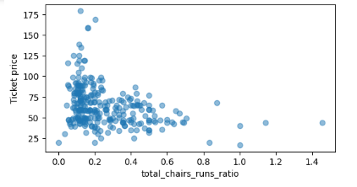

It shows that with more chairs the price did not increase. At low amounts of chairs some resorts, due to high demand, raised the ticket prices, but again, they, being smaller, can not make a big revenue.

The fast quads are required, as we see from the figures that having no fast quads limits the ticket prices. But too many fast quads do not help. With limited fast quads prices can be raised.

Modeling:

For training and testing, we had separated out the Big mountain Resort data and then for the rest of the data, we split it into 70/30 to train and test the fitting model. We tried the fitting in many different ways and finally decided on random forest model. Now, when we checked for Big Mountain in some major parameters, we found it to be at an above average state. These parameters are Vertical Drop, Snow Makers Area, Total Chairs, Fast Quads, Runs, Longest Run in miles, no of Trams, Skiable Terrain Area. So we combined these data and fit them with the fitting model to understand what change in the ticket will be the best for us. We analyzed the following scenarios:

1. Closing least used runs: We checked the outcome of closing of upto 10 least used runs. Below is the figure. It suggests that closing upto 5 least used runs will reduce the ticket price by 70 cents

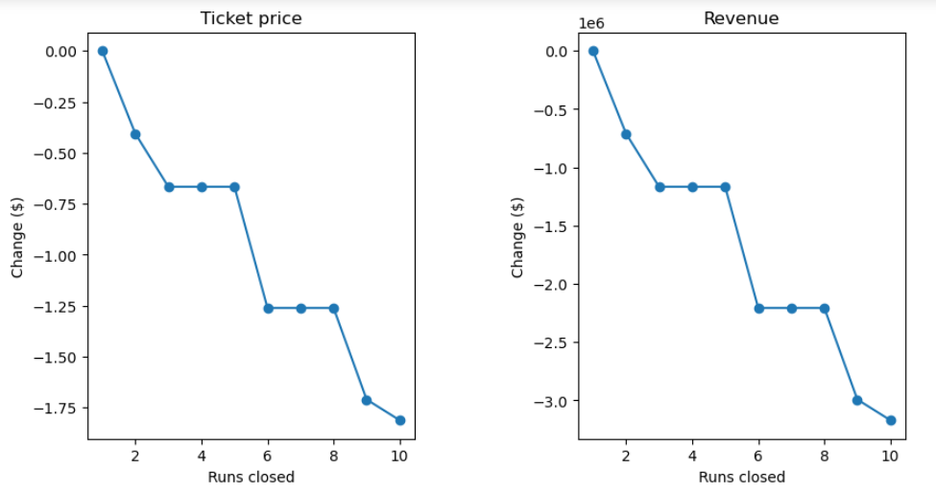

and the revenue by around $1.2. More than 5 will make a significant drop in the ticket price and revenue. Now, this action will reduce the maintenance and preparation costs of the runs. But we don’t have a data for that, so we can not make a remark on the profit.

1. Adding a run, increasing the vertical drop by 150 ft and introducing an additional chair. This incr-eases the ticket price by $8.61 and revenue over the season by $15065471
2. We checked if with (2) we add 2 acers of snow using snow making machine. The increase in price and revenue are insignificant, about 15%. Installation of snow machine and maintenance cost will be more.
3. Increasing the longest run by 2 miles and guarantee snow for 4 acers by installing machines. We found no change in ticket price and revenue with this change.